DEPARTMENT OF
COMPUTER SCIENCE AND ENGINEERING (CYBER SECURITY)

LAB REPORT

for the course
Multicore Architecture and Programming
CY71

for the academic year
2025-2026

Submitted by:
Rajat Tripathi - 1MS22CY058

Certificate

This is to certify that Rajat Tripathi (1MS22CY058) has satisfactorily completed the course of experiments in the practical of Multicore Architecture and Programming (CY71) prescribed by the Department of CSE (Cyber Security), Ramaiah Institute of Technology for the year 2025-2026.

Component | Max. Marks | Marks Obtained
Record
Lab Test
Total Marks

Signature of Student with Date Signature of Faculty with Date

Program 1: Basic Multi-Core Matrix Addition
Implement parallel processing to calculate the sum of a 2D array.
Code:
#include <stdio.h>
#include <pthread.h>
#define SIZE 3
int A[SIZE][SIZE] = { {1, 2, 3}, {4, 5, 6}, {7, 8, 9} };
int B[SIZE][SIZE] = { {9, 8, 7}, {6, 5, 4}, {3, 2, 1} };
int C[SIZE][SIZE];
void *add_matrices(void* arg){
int i = *(int*)arg;
for(int j = 0; j < SIZE; j++)
C[i][j] = A[i][j] + B[i][j];
return NULL;}
int main(){
pthread_t threads[SIZE];
int indices[SIZE];
for(int i = 0; i < SIZE; i++) {
indices[i] = i;
pthread_create(&threads[i], NULL, add_matrices, (void*)&indices[i]); }
for(int i = 0; i < SIZE; i++)
pthread_join(threads[i], NULL);
printf("Resultant matrix:\n");
for(int i = 0; i < SIZE; i++) {
for(int j = 0; j < SIZE; j++)
printf("%d ", C[i][j]);
printf("\n"); }
return 0;}

Output:
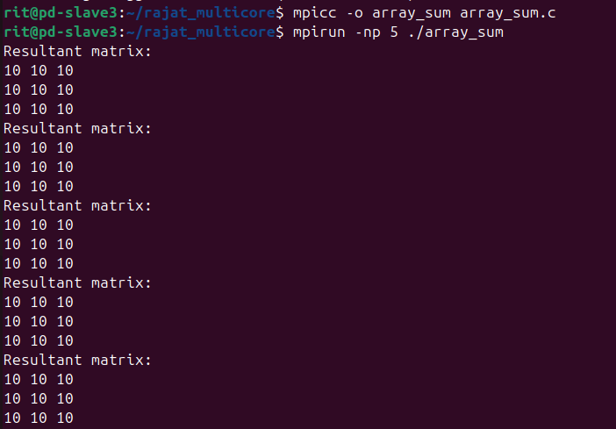

Program 2: Simple Multi-Core Factorial Calculation
Implement parallel processing to calculate the factorials of large numbers.
Code:
#include <stdio.h>
#include <pthread.h>
#define NUM_THREADS 4
long long results[NUM_THREADS];
void* factorial(void* arg) {
int thread_id = *(int*)arg;
long long fact = 1;
for (int i = 1; i <= 5 + thread_id; i++) {
fact *= i; }
results[thread_id] = fact;
return NULL;}
int main() {
pthread_t threads[NUM_THREADS];
int thread_ids[NUM_THREADS];
for (int i = 0; i < NUM_THREADS; i++) {
thread_ids[i] = i;
pthread_create(&threads[i], NULL, factorial, (void*)&thread_ids[i]); }
for (int i = 0; i < NUM_THREADS; i++) {
pthread_join(threads[i], NULL);
printf("Factorial computed by thread %d: %lld\n", i, results[i]); }
return 0;}

Output:
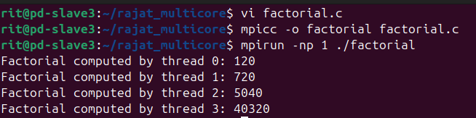

Program 3: Parallel Search in an Array
Implement multithreading to simulate searching large datasets, such as user records in a database.
Code:
#include <stdio.h>
#include <pthread.h>
#define SIZE 100
int data[SIZE];
int found_index = -1;
pthread_mutex_t lock;
void* search(void* arg) {
int start = *(int*)arg;
for (int i = start; i < start + SIZE / 4; i++) {
if (data[i] == 50) {
pthread_mutex_lock(&lock);
found_index = i;
pthread_mutex_unlock(&lock);
return NULL; } }
return NULL;}
int main() {
pthread_t threads[4];
int thread_ids[4];
for (int i = 0; i < SIZE; i++) {
data[i] = i + 1; }
pthread_mutex_init(&lock, NULL);
for (int i = 0; i < 4; i++) {
thread_ids[i] = i * (SIZE / 4);
pthread_create(&threads[i], NULL, search, (void*)&thread_ids[i]); }
for (int i = 0; i < 4; i++) {
pthread_join(threads[i], NULL); }
if (found_index != -1) {
printf("Number 50 found at index: %d\n", found_index);
} else {
printf("Number 50 not found.\n"); }
pthread_mutex_destroy(&lock);
return 0;}

Output:
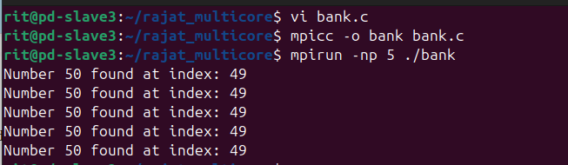

Program 4: Parallel Sorting with Merge Sort
Implement multithreading to simulate sorting large datasets in common applications, such as database management systems.
Code:
#include <stdio.h>
#include <pthread.h>
#include <stdlib.h>
#define SIZE 100
int array[SIZE];
int temp[SIZE];
void merge(int left, int mid, int right) {
int i = left, j = mid + 1, k = left;
while (i <= mid && j <= right) {
if (array[i] < array[j]) {
temp[k++] = array[i++];
} else {
temp[k++] = array[j++]; } }
while (i <= mid) {
temp[k++] = array[i++]; }
while (j <= right) {
temp[k++] = array[j++]; }
for (i = left; i <= right; i++) {
array[i] = temp[i]; }}
void merge_sort_range(int left, int right) {
if (left < right) {
int mid = (left + right) / 2;
merge_sort_range(left, mid);
merge_sort_range(mid + 1, right);
merge(left, mid, right); }}
void* merge_sort(void* arg) {
int left = *(int*)arg;
int right = left + (SIZE / 4) - 1;
merge_sort_range(left, right);
return NULL; }
int main() {
pthread_t threads[4];
int thread_ids[4];
for (int i = 0; i < SIZE; i++) {
array[i] = rand() % 1000; }
for (int i = 0; i < 4; i++) {
thread_ids[i] = i * (SIZE / 4);
pthread_create(&threads[i], NULL, merge_sort, (void*)&thread_ids[i]);}
for (int i = 0; i < 4; i++) {
pthread_join(threads[i], NULL); }
int quarter = SIZE / 4;
merge(0, quarter - 1, 2 * quarter - 1);
merge(2 * quarter, 3 * quarter - 1, SIZE - 1);
merge(0, 2 * quarter - 1, SIZE - 1);
printf("Sorted Array:\n");
for (int i = 0; i < SIZE; i++) {
printf("%d ", array[i]); }
printf("\n");
return 0; }

Output:
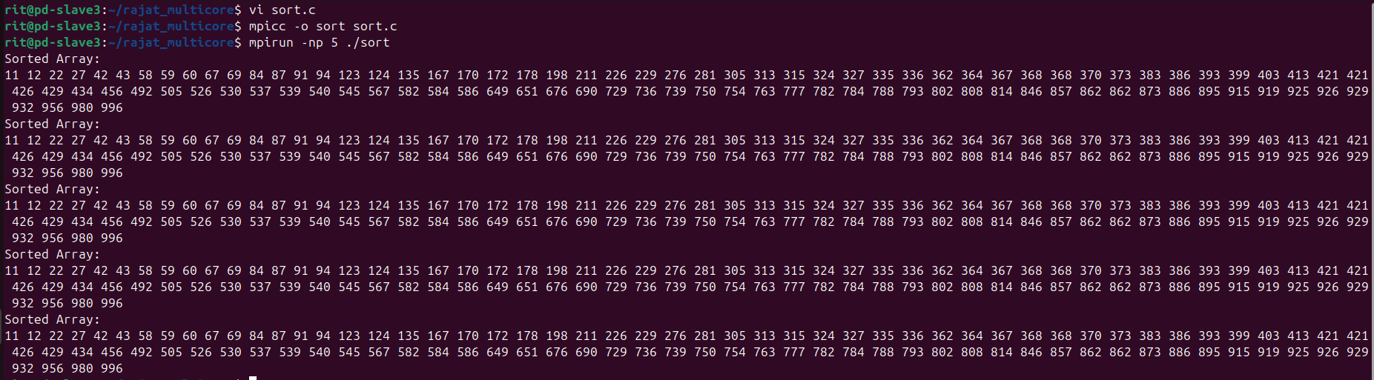

Program 5: Mutex for Synchronization
Implement multi-threading to simulate concurrent bank transactions using mutex locks.
Code:
#include <stdio.h>
#include <pthread.h>
#define NUM_THREADS 5
int account_balance = 1000;
pthread_mutex_t lock;
void* perform_transaction(void* arg) {
int amount = *((int*)arg);
pthread_mutex_lock(&lock);
if (account_balance + amount >= 0) {
account_balance += amount;
printf("Transaction successful. New balance: %d\n", account_balance);
} else {
printf("Transaction denied. Insufficient funds.\n"); }
pthread_mutex_unlock(&lock);
return NULL; }
int main() {
pthread_t threads[NUM_THREADS];
int transactions[NUM_THREADS] = {-200, 100, -300, 150, -400};
pthread_mutex_init(&lock, NULL);
for (int i = 0; i < NUM_THREADS; i++) {
pthread_create(&threads[i], NULL, perform_transaction, (void*)&transactions[i]); }
for (int i = 0; i < NUM_THREADS; i++) {
pthread_join(threads[i], NULL); }
printf("Final account balance: %d\n", account_balance);
pthread_mutex_destroy(&lock);
return 0; }

Output:
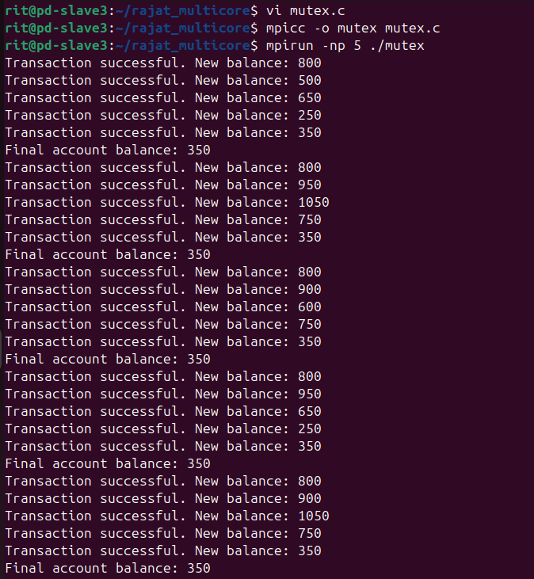

Program 6: Condition Variables for Thread Communication
Implement a producer-consumer model using threads for task management. Here, we use the concept of a bakery, where bakers (producers) need to signal when bread is ready for delivery (consumers).
Code:
#include <stdio.h>
#include <pthread.h>
#include <unistd.h>
#define MAX_BREAD 10
int bread_count = 0;
pthread_mutex_t lock;
pthread_cond_t cond;
void* producer(void* arg) {
while (1) {
pthread_mutex_lock(&lock);
while (bread_count >= MAX_BREAD) {
pthread_cond_wait(&cond, &lock); }
bread_count++;
printf("Produced bread. Total: %d\n", bread_count);
pthread_cond_signal(&cond);
pthread_mutex_unlock(&lock);
sleep(1); }
return NULL;}
void* consumer(void* arg) {
while (1) {
pthread_mutex_lock(&lock);
while (bread_count <= 0) {
pthread_cond_wait(&cond, &lock); }
bread_count--;
printf("Consumed bread. Total: %d\n", bread_count);
pthread_cond_signal(&cond);
pthread_mutex_unlock(&lock);
sleep(2); }
return NULL;}
int main() {
pthread_t prod_thread, cons_thread;
pthread_mutex_init(&lock, NULL);
pthread_cond_init(&cond, NULL);
pthread_create(&prod_thread, NULL, producer, NULL);
pthread_create(&cons_thread, NULL, consumer, NULL);
pthread_join(prod_thread, NULL);
pthread_join(cons_thread, NULL);
pthread_mutex_destroy(&lock);
pthread_cond_destroy(&cond);
return 0;}

Output:
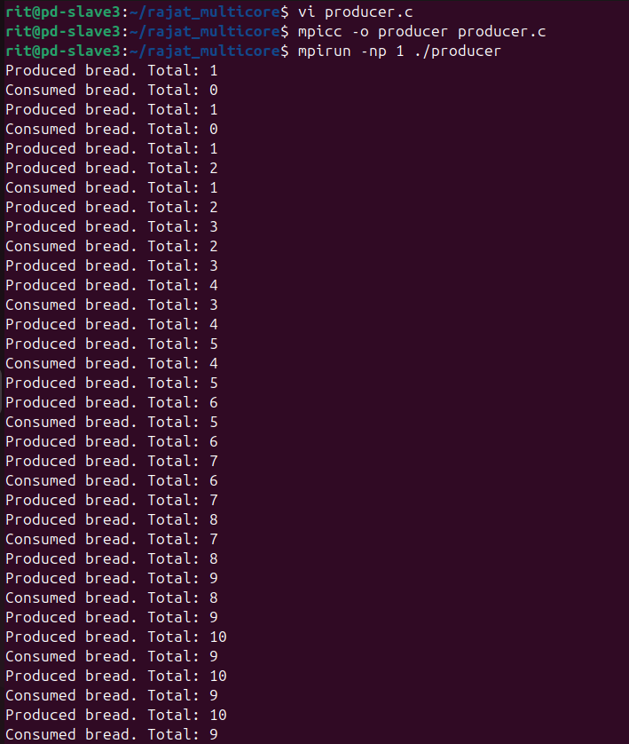

Program 7: OpenMP Parallel Loop
Implement parallel array summation using OpenMP for performance optimization.
Code:
#include <stdio.h>
#include <omp.h>
#include <stdlib.h>
#define SIZE 1000000
int array[SIZE];
int main() {
for (int i = 0; i < SIZE; i++) {
array[i] = rand() % 100;}
#pragma omp parallel{
if (omp_get_thread_num() == 0) {
printf("Running with %d threads\n", omp_get_num_threads()); }}
int sum = 0;
#pragma omp parallel for reduction(+:sum)
for (int i = 0; i < SIZE; i++) {
sum += array[i];}
printf("Total Sum: %d\n", sum);
return 0;}

Output:
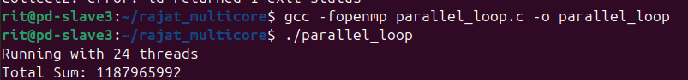
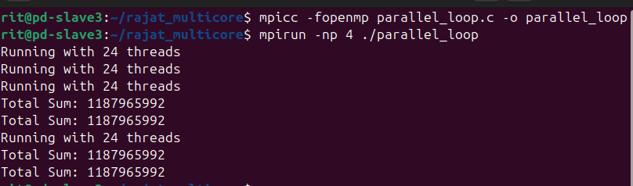

Program 8: OpenMP Task Parallelism
Implement task parallelism in image processing applications using OpenMP.
Code:
#include <stdio.h>
#include <omp.h>
#define NUM_TASKS 4
void blur() {
printf("Blurring the image...\n");}
void sharpen() {
printf("Sharpening the image...\n");}
void contrast() {
printf("Adjusting contrast...\n");}
void resize() {
printf("Resizing the image...\n");}
int main() {
#pragma omp parallel {
#pragma omp single {
int num_threads = omp_get_num_threads();
printf("Running with %d OpenMP threads\n", num_threads);
#pragma omp task
blur();
#pragma omp task
sharpen();
#pragma omp task
contrast();
#pragma omp task
resize(); } }
return 0;}

Output:
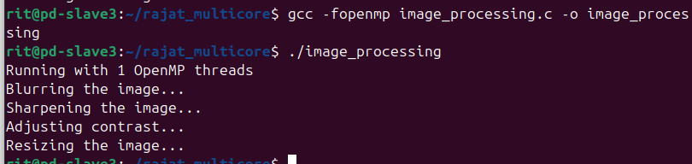
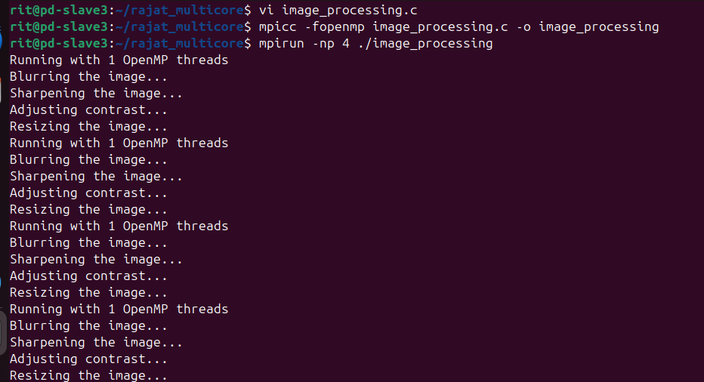

Program 9: Handling Deadlocks with Timeouts
Implement timeout mechanisms to handle deadlocks effectively.
Code:
#include <stdio.h>
#include <pthread.h>
#include <unistd.h>
#define NUM_THREADS 2
pthread_mutex_t lock1;
pthread_mutex_t lock2;
void* thread_function(void* arg) {
int thread_id = *(int*)arg;
if (thread_id == 0) {
pthread_mutex_lock(&lock1);
sleep(1);
printf("Thread 0: Waiting for lock 2...\n");
if (pthread_mutex_trylock(&lock2) != 0) {
printf("Thread 0: Failed to acquire lock 2, releasing lock 1.\n");
pthread_mutex_unlock(&lock1);
} else {
printf("Thread 0: Acquired both locks, doing work...\n");
sleep(1);
pthread_mutex_unlock(&lock2);
pthread_mutex_unlock(&lock1); }
} else {
pthread_mutex_lock(&lock2);
sleep(1);
printf("Thread 1: Waiting for lock 1...\n");
if (pthread_mutex_trylock(&lock1) != 0) {
printf("Thread 1: Failed to acquire lock 1, releasing lock 2.\n");
pthread_mutex_unlock(&lock2);
} else {
printf("Thread 1: Acquired both locks, doing work...\n");
sleep(1);
pthread_mutex_unlock(&lock1);
pthread_mutex_unlock(&lock2); } }
return NULL;}
int main() {
pthread_t threads[NUM_THREADS];
int thread_ids[NUM_THREADS] = {0, 1};
pthread_mutex_init(&lock1, NULL);
pthread_mutex_init(&lock2, NULL);
for (int i = 0; i < NUM_THREADS; i++) {
pthread_create(&threads[i], NULL, thread_function, (void*)&thread_ids[i]); }
for (int i = 0; i < NUM_THREADS; i++) {
pthread_join(threads[i], NULL); }
pthread_mutex_destroy(&lock1);
pthread_mutex_destroy(&lock2);
return 0;}

Output:
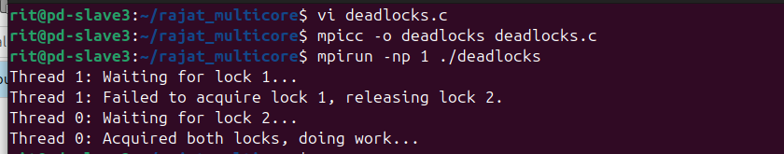
Program 10: Work-Stealing Scheduler
Implement a work-stealing scheduler to optimize task processing among threads.
Code:
#include <stdio.h>
#include <pthread.h>
#include <stdlib.h>
#include <unistd.h>
#define NUM_TASKS 10
#define NUM_THREADS 4
int tasks[NUM_TASKS];
void* process_tasks(void* arg) {
int thread_id = *(int*)arg;
for (int i = thread_id; i < NUM_TASKS; i += NUM_THREADS) {
printf("Thread %d processing task %d\n", thread_id, tasks[i]);
sleep(1);}
return NULL;}
int main() {
pthread_t threads[NUM_THREADS];
int thread_ids[NUM_THREADS];
for (int i = 0; i < NUM_TASKS; i++) {
tasks[i] = i + 1;}
for (int i = 0; i < NUM_THREADS; i++) {
thread_ids[i] = i;
pthread_create(&threads[i], NULL, process_tasks, (void*)&thread_ids[i]);}
for (int i = 0; i < NUM_THREADS; i++) {
pthread_join(threads[i], NULL);}
return 0;}
Output:
